**FACIAL RECOGNITION DOOR WITH**

**RASPBERRY PI**

*Project report submitted in partial fulfillment of the requirements for the degree*

*of*

**BACHELOR OF VOCATION**

**IN**

**INTERNET OF THINGS**

By

**Khushi Gupta (1904701)**

**Neelu Devi (1904707)**

**Priyanshi Gola (1904710 )**

**Km. Radha (1904711)**

UNDER THE GUIDANCE OF

**Dr. R.S. PAVITHR**

**&**

**Mr. Umesh Tyagi**

DEPARTMENT OF PHYSICS AND COMPUTER SCIENCE

DAYALBAGH EDUCATIONAL INSTITUTE, AGRA

**DECLARATION**

We hereby declare that the work reported in the IOT thesis entitled **“Facial recognition door with raspberry Pi ”** submitted at Dayalbagh Educational Institue, Agra, is an authentic record of our work carried out under the supervision of  **Amar sir**. We have not submitted this work elsewhere for any other degree.

Khushi Gupta (1904701)

Neelu Devi (1904707)

Priyanshi gola ( 1904710)

Km. Radha (1904711)

Department of Physics and Computer Science

Dayalbagh Educational Institute, Agra

**CERTIFICATE**

This is to certify that the work reported in the IOT. thesis entitled **“Facial recognition door with raspberry Pi”**, submitted by **Khushi Gupta, Neelu Devi, Priyanshi gola, Km. Radha,**  at Dayalbagh Educational Institute, Agra, is a bonafide record of their original work carried out under my supervision. This work has not been submitted elsewhere for any other degree.

Dr. R.S. Pavithr

Dept. of Physics & Computer Science

**ACKNOWLEDGEMENT**

We would like to thank Mr. Amarjeet Sir, for providing us the opportunity of working on a project.

We are highly indebted to Dr. R.S. Pavithr for motivating and enlightening us for our project work. We thank you for being a constant support throughout, without whose valuable guidance and insights, this project would not be a complete one. We offer you our sincere gratitude to you for instructing and directing us through thick and thin.

Thank you for being there and helping us in and out.

**ABSTRACT**

Mostly doors can be open by the traditional ways, such as keys, security cards, passwords, etc. However, incident such as key loss has led to much worrying case such as robbery, and identify fraud. This has become a significant issue. To overcome this problem, Face recognition using deep learning technique was introduced and Internet of Things (Iot) also been used to perform efficient door access control system. Raspberry Pi is a programmable small computer board and used as the main controller for face recognition locking system. The camera is used to capture the image of a person in front of the door. IoT system enables the user to control the door access.

**Introduction:-**

A **facial recognition system** is a technology capable of [identifying](https://en.wikipedia.org/wiki/Identification_of_human_individuals) or [verifying](https://en.wikipedia.org/wiki/Authentication) a person from a [digital image](https://en.wikipedia.org/wiki/Digital_image) or a [video frame](https://en.wikipedia.org/wiki/Film_frame) from a video source. The proposed face recognition door lock security system has been developed to prevent robbery in highly secure areas like home environment with lesser power consumption and more reliable standalone security device for both Intruder detection and for door security. This system is powered by raspberry pi circuit. Raspberry Pi electronic board is operated on Battery power supply, it includes camera, and a door. Whenever the person comes in front of the door, it recognizes the face and if it is registered then it unlocks the door, if the face is not registered it will raise an alarm and clicks a picture and send it on the registered number. This is how the system works.

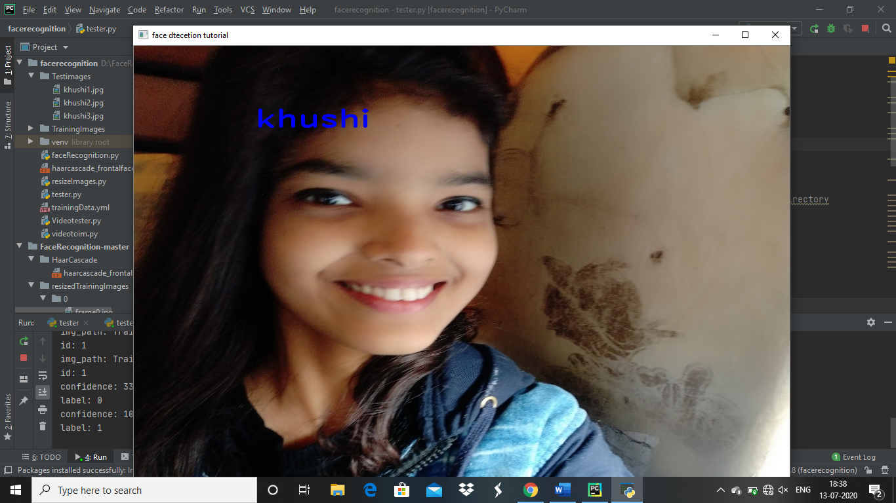

+

**Hardware Requirements :-**

* Rasberry-Pi
* Solenoid Lock
* External DC power source
* Relay module
* Rasberry Pi camera
* Jumper Wires
* **Raspberry Pi:-**

The Raspberry Pi is a low cost, credit-card sized computer that plugs into a computer monitor or TV, and uses a standard keyboard and mouse. It is a capable little device that enables people of all ages to explore computing, and to learn how to program in languages like Scratch and Python.

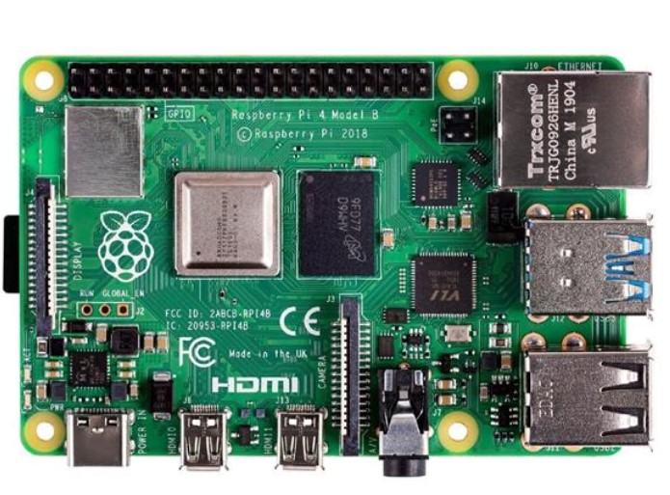

* **Solenoid lock:-**

The solenoid lock denotes a latch for electrical locking and unlocking. It is available in unlocking in the power-on mode type, and locking and keeping in the power-on mode type, which can be used selectively for situations. The power-on unlocking type enables unlocking only while the solenoid is powered on.

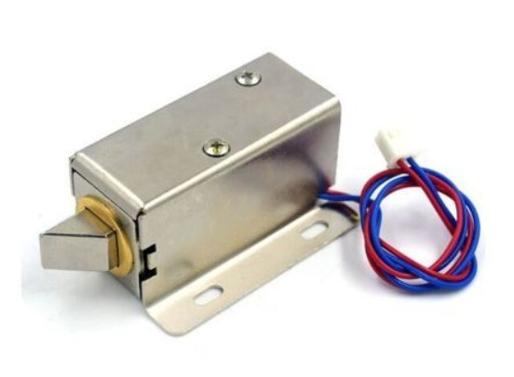

* **External DC source:-**

A DC power supply is one that supplies a constant DC voltage to its load. Depending on its design, a DC power supply may be powered from a DC source or from an AC source such as the power mains. A DC power supply can be constructed as an electronic circuit operating from the ac mains electricity supply and designed for purpose.

* **Rasberry Pi camera:-**

The Raspberry Pi Camera Module v2 replaced the original Camera Module in April 2016. The v2 Camera Module has a Sony IMX219 8-megapixel sensor (compared to the 5-megapixel OmniVision OV5647 sensor of the original camera).The Camera Module can be used to take high-definition video, as well as stills photographs. The camera works with all models of Raspberry Pi 1, 2, 3 and 4.

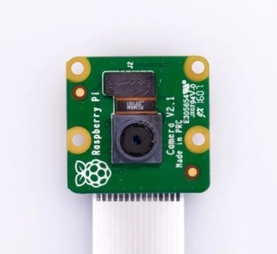

* **Jumper Wires:-**

**Jumper wires** are simply **wires** that have connector pins at each end, allowing them to be **used** to connect two points to each other without soldering. **Jumper wires** are typically **used with** breadboards and other prototyping tools in order to make it easy to change a circuit as needed.

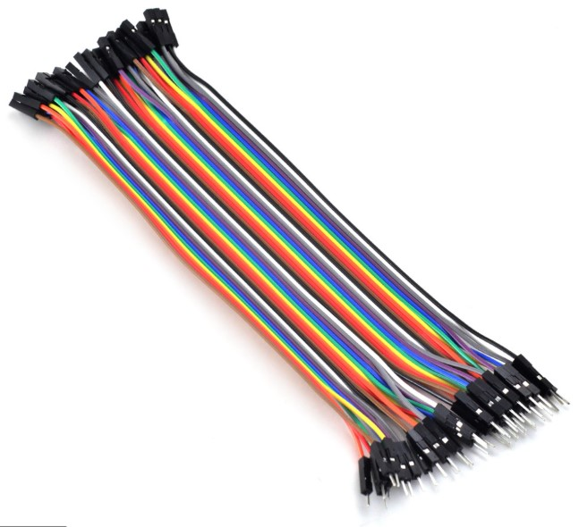

* **Relay module:-**

The relay module is a separate hardware device used for remote device switching. With it you can remotely control devices over a network or the Internet. Devices can be remotely powered on or off with commands coming from Clock Watch Enterprise delivered over a local or wide area network.  You can control computers, peripherals or other powered devices from across the office or across the world. The Relay module can be used to sense external On/Off conditions and to control a variety of external devices. The PC interface connection is made through the serial port.

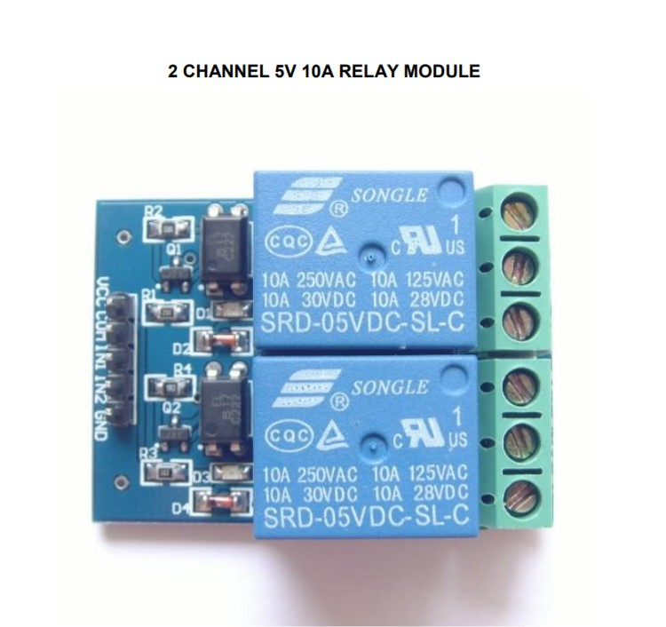

### Circuit Diagram and Explanation

The [GPIO pins of the Raspberry Pi](https://maker.pro/raspberry-pi/projects/gpio-controlling-of-the-raspberry-pi) can give an output of 3.3V but the solenoid lock requires 7-12V to operate. Because of this, we will need to use an external power source and relay to operate the lock.

Connect the VCC and GND of the relay module to 5V and GND of Raspberry Pi. Then connect the signal pin of the relay module to the GPIO 26 of Raspberry Pi.

On the other side of the relay module, connect the negative form DC power source to the negative of the solenoid door lock. Connect the positive from the DC power source to the common of the relay module and then connect normally open from the relay module to positive of the solenoid door lock.

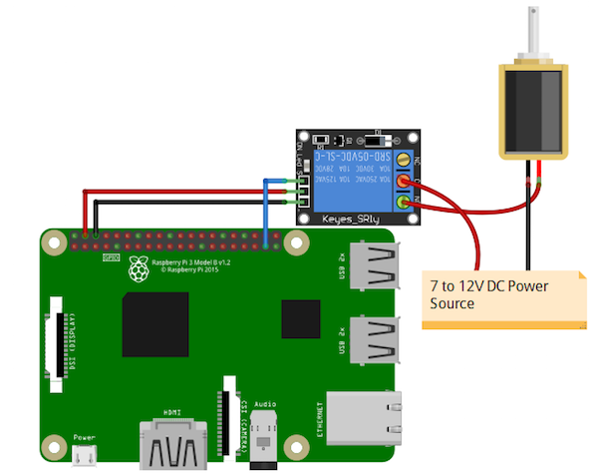

### Face Detection Complete Code:-

### Application:-

### 1. Security companies are using facial recognition to secure their premises.

### 2. Immigration checkpoints use facial recognition to enforce smarter border control.

### 3. Fleet management companies can use face recognition to secure their vehicles.

### 4. Ride-sharing companies can use facial recognition to ensure the right passengers are picked up by the right drivers.

### 5. IoT benefits from facial recognition by allowing enhanced security measures and automatic access control at home.

### 6. Law Enforcement can use facial recognition technologies as one part of AI-driven surveillance systems.

### 7. Retailers can use facial recognition to customize offline offerings and to theoretically map online purchasing habits with their online ones.

**Future of Facial Recoginition:-**

Today, one of the fields that uses facial recognition the most is security. Facial recognition is a very effective tool that can help law enforcers recognize criminals and software companies are leveraging the technology to help users access their technology. This technology can be further developed to be used in other avenues such as ATMs, accessing confidential files, or other sensitive materials. This can make other security measures such as passwords and keys obsolete.

**Advantages:-**

1.Improved Public security

2.Fast and non-invasiveidentity verification

3.Benefits of facial recoginition in Banking

4. Benefits of facial recoginition in Retail.

5. Better worker attendance system

## 6.  Face Recognition Furthers Enables Computer Vision.

**Conclusion:-**

**Face recognition** technology has come a long way in the last twenty years. Today, machines are able to automatically verify identity information for secure transactions, for surveillance and security tasks, and for access control to buildings etc. These applications usually work in controlled environments and recognition algorithms can take advantage of the environmental constraints to obtain high recognition accuracy.